EP Net User Guide

NRG Plus
Web site: www.energyplus.com

Table of Contents
About the Company 2
About EP NET 2
Overview 2
How EP Net Works 2
Operations 3
Work Queue 3
Customer Enrollment Validations 3
Requires Review: Reject Type 4
Duplicate within File: Reject Type 6
Possible Match: Reject Type 7
Reject Type: Possible Duplicate 8
Reject Type: Possible VIPs 8
Reject Type: Utility Rejects 8
Searching Records 9
AdHoc Awards 11

About the Company

NRG Plus (originally named Energy Plus) was founded in 2007 by several resourceful entrepreneurs who brought their innovative approach to the New York deregulated electricity market.
Since then, the company has grown to provide electricity service in eight states and natural gas service in three states, with almost 150,000 customers enrolled in over a dozen rewards options.
NRG Plus has always been a proponent of renewable energy sources -- clean sources of energy that have a much lower environmental impact than conventional energy technologies. So, along with its other product offerings, the company provides its electricity customers with a Green option. The Green Option helps support the environment by using 100 percent pure wind power, one of the cleanest forms of available electricity produced without greenhouse emissions.
In 2011 Energy Plus was purchased by NRG in Princeton, NJ and rebranded itself as NRG Plus.
As NRG Plus continues its evolution, its customers can expect new markets, new products, and new rewards offerings to be launched over time – while the company continues to focus on continually providing outstanding, reliable customer service and customer friendly policies.
At NRG Plus, the customers benefit from the money they already spend each month on utilities through a unique rewards program featuring cash back, airline miles, hotel and retail points, and college savings from more than 80 industry-leading partners, and associations. In other words, NRG Plus customers make their energy bills work for them and receive a bonus just for enrolling!
Headquartered in Philadelphia, PA NRG Plus serves Connecticut, Illinois, Maryland, New Jersey, New York, Texas and most of Pennsylvania.

About EP NET

Overview
EP Net is NRG Plus’ proprietary, internal .net application specifically designed to manage the company’s core processing. The application enables the company’s business areas to perform their day-t0-day activities.

How EP Net Works
EP Net uses an easy-to-use, tabular format with six main functional areas: Operations, Marketing, Customer Service, Finance, Partners, and Sales. And, as NRG Plus continues to expand its business areas, EP Net is also evolving as NRG Plus teams work to increase the application’s scalability, reliability, add new business areas, and improve its overall functionality.
The purpose of this User Guide is to provide you with comprehensive information on the functionality of EP Net and provide assistance in using the application while performing your day-to-day tasks.
Welcome to the NRG Plus team!

Operations
The NRG Plus Operations team manages the flow of data, validates the quality of that data, and identifies production issues to help ensure the best customer experience for NRG Plus customers. The primary processes addressed by Operations are: Enrollments, Pricing, Billing, Awards, and Payments.

Work Queue

Customer Enrollment Validations
The Work Queue option is the work area used by the NRG Plus Operations team for performing tasks related to the Customer Enrollment process.
As you can see from the screen shot below, the Work Queue menu option is available under the Operations tab.
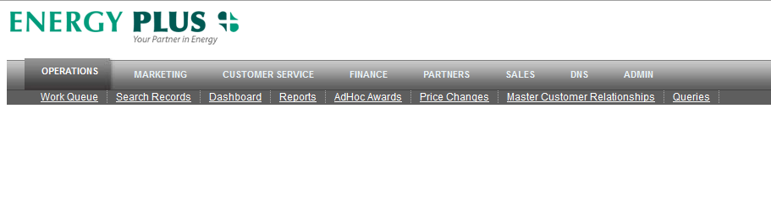
Figure 1: Operation tab
Because NRG Plus customers are enrolled through a variety of channels, errors sometimes occur in Enrollment records and the EP Net system automatically flags those records with a Reject Type. Once this occurs, steps need to be taken to resolve the issues.
Customer Enrollment records flagged with a Reject Type occur for various reasons (i.e., typos, missing information, duplicate information, etc.) and are sorted into several categories: Pre-Enrollment (Duplicate within File, Possible Duplicate, Possible Match, Possible VIP, and Requires Review), Utility, and ISTA.
- A Pre-Enrollment rejection means that the Customer Enrollment Record did not pass the NRG Plus validation process.
- A Utility rejection means that the Customer Enrollment Record passed the NRG Plus validation process but failed the Utility validation process.
- An ISTA rejection means that the Customer Enrollment Record passed the NRG Plus validation process but failed the ISTA validation process.
The Work Queue screen allows you to search Customer Enrollment records by: State, Service Phone, Utility Account Number, and Energy Plus ID. And, you can filter your search by State, User, Marketer ID (MID) **, and Reject Type.
**The Marketer ID (MID) designates how a NRG Plus account was enrolled. The 9,000 designation means the account was enrolled via the NRG Plus web site; D2D means the account was enrolled by door-t0-door marketing, and PGSO, RDIN, and TMCI designate that the account was enrolled through telemarketing.

Requires Review: Reject Type
The following instructions will walk you through the steps required to address a Requires Review reject type in a Customer Enrollment record.
Ready? Let’s get started.
- Navigate to <INSERT URL ONCE GUI IS COMPLETE>
- Select Operations > Work Queue
- The Work Queue screen displays
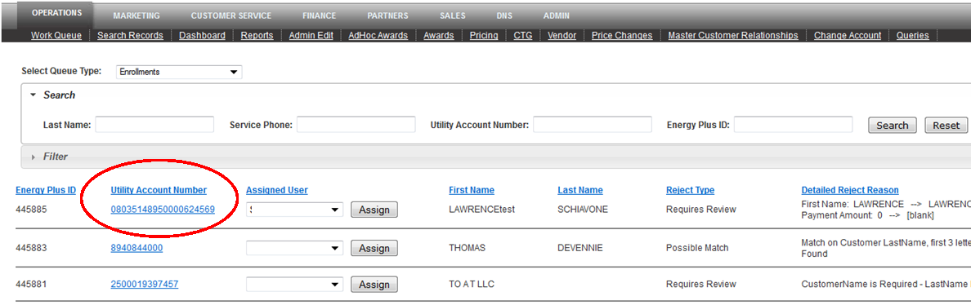
Figure 2: Operations Work Queue Enrollment Record
- Select Enrollments from the Select Queue Type: pull-down menu
- Navigate to the first record in the queue.
- Check the Assigned User field to see if the task has been assigned to a specific person. If so, move on to the next record. If not, select this record’s account number listed under the Utility Account Number heading.
- The expanded record for the selected account number displays.
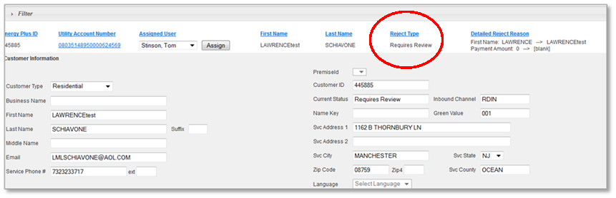
Figure 3: Expanded Enrollment Record
- Review the reason for the rejection under the Reject Type heading. In this example, the reason listed is Requires Review. This particular Reject Type usually requires an investigation.
You can also view the Reject Type in the Current Status field on the Work Queue screen.
- Scroll down to the Comments section to view the information related to why the record was flagged with a Reject Type.
- If possible, correct the outstanding issue yourself and select the Save Changes button.
- Once all of the changes to the record are completed, select the Save & Reprocess button to ‘save and reprocess’ the record.
- If you cannot correct the issue yourself and the customer needs to get involved, select the Customer Service Follow-Up option from the Change Status To: field located at the bottom of your screen.
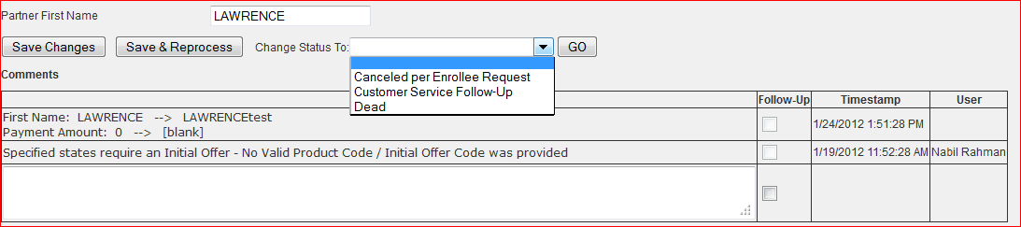
Figure 4: Change Status To: pull-down menu
- Enter a comment in the Comments field explaining what needs to be done to address the outstanding issue.
- Select the Add New button to add your comment to the record.
- If you feel that the issue requires Customer Service assistance, select the Calendar icon next to the Create as Follow-Up Reminder field to select a follow up date. This feature is used as a ‘friendly’ reminder.
- Select the Create Follow Up Reminder button. The follow up date is recorded.
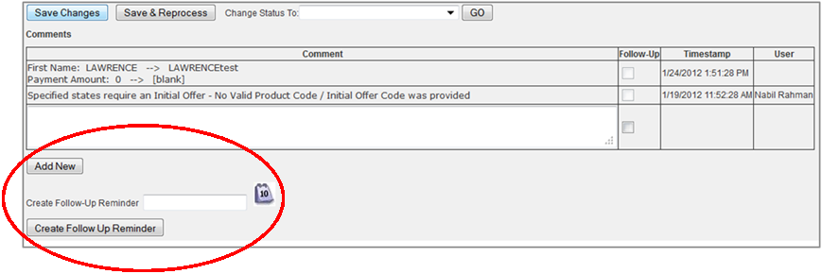
Figure 5: Create Follow Up Reminder button and Calendar icon
- Click the Save Changes button.
Click the Save & Reprocess button. The record will now be routed to Customer Service who will contact the NRG Plus customer.
If an account’s status is Requires Review and the item that is ‘missing’ is the Service Telephone Number, you can enter a ‘fake’ telephone number and send the record through rather than re-routing it to Customer Service. The reason for this is NRG Plus has other ways to contact the customer, such as email, cell phone, etc.

Duplicate within File: Reject Type
The following instructions will walk you through the steps required to address a Duplicate within File reject type in a Customer Enrollment record.
Ready? Let’s get started.
The Duplicate within File Reject Type occurs when the system contains two (or more) records with the same account number. In most cases Duplicate within File Reject Types are re-routed to Customer Service as the customer needs to be contacted. However, there are times when the issue can be resolved by the Operations team.
- Open the matching records and carefully examine each record to make sure that all of the information matches including the Promo partners.
- Carefully examine the time stamp as if the time stamp is seconds apart it usually means that the customer inadvertently selected the Submit button more than once – thus creating more than one record with the same account number. If this is the case, you can ‘dead’ one of the accounts and do not have to re-route it to Customer Service.
Dead means that the enrollment process was never completed by the customer.

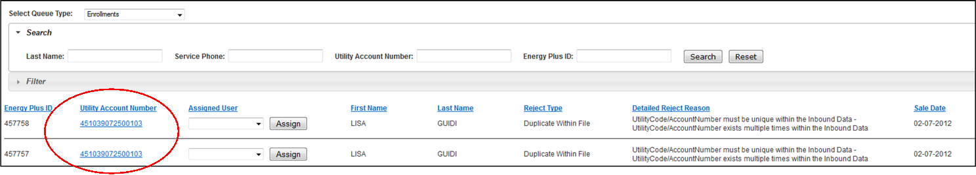
Figure 6: Duplicate Records
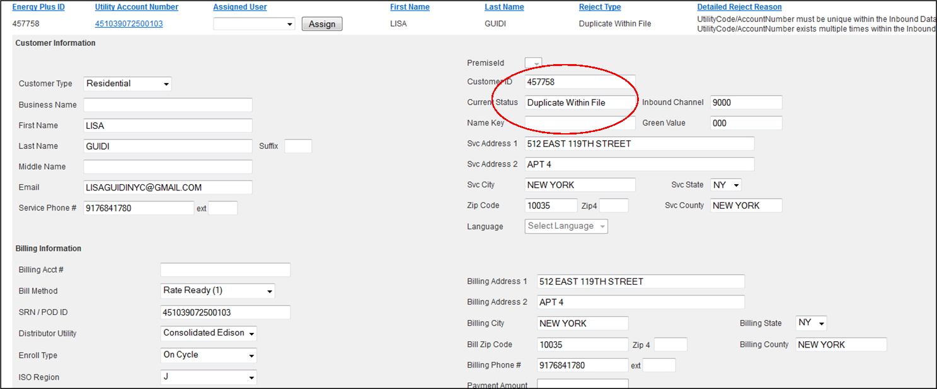
Figure 7: Reject Type: Duplicate within File
- Once you have examined the records and are sure that the account is a Duplicate with a File, select the Utility Account Number that you want to remove from the system.
- Once the Customer Account Record displays, select Dead from the Change Status To pull down menu for the ‘dead’ record.
- Select the Save and Reprocess button. The record has been removed from the system and the customer now has one record attached to his/her Account number.
- Open the remaining record and select the Save & Reprocess button.
Although records that display the status Duplicate within File have the same account number as well as other like information, the difference may be the Promo partners. This is a situation where the Record would be re-routed to Customer Service as the customer needs to be contacted.
- Open the Record.
- Enter a note in the Comments section explaining the issue.
- Select the Add New button. Your comment is now added to the account.
- Select the Change Status To pull down menu at the bottom of your screen.
- Choose Customer Service Follow Up.
- Select the Add New button to add the follow up date to the account.
- The Record will be re-routed to Customer Service.

Possible Match: Reject Type
The next type of Reject Type is Possible Match. This occurs when some of the information in one account matches information in another account.
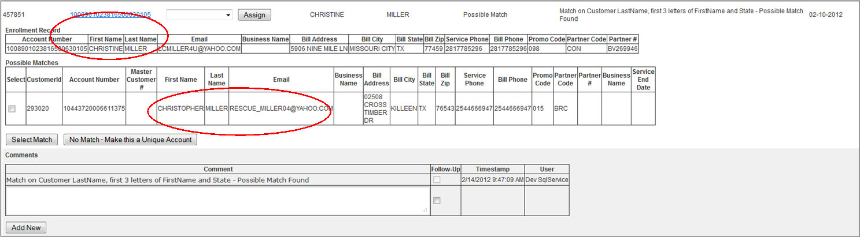
Figure 8: Reject Type: Possible Match
- Select the Record with the status Possible Match.
- Review the possible match reason under the Detailed Reject Reason heading.
- Open the Record by selecting the Record’s Account Number listed under the Utility Account Number heading.
- The Customer Record screen displays showing the other accounts that may be a possible match. Review the information in the other accounts to determine if there is a possible match.
- If it’s a match, select the Select Match button.
- If it’s not a match, select the No Match –Make this a Unique Account button.
- The Work Queue screen displays with the message: The record with Utility Acct # <XYZ> has been marked as Not a Match.

Reject Type: Possible Duplicate
A Possible Duplicate usually refers to two customer records that have the same account number with one of those accounts listed as Inactive.
When an account is listed as Inactive it usually refers to a customer account that was previously enrolled at NRG Plus. For example: The customer linked to an Inactive account was an NRG Plus customer in the past, dropped NRG Plus, and rejoined at a later date
- If you’re sure that it’s a Possible Duplicate, select the Confirm Duplicate button.

Reject Type: Possible VIPs
An account with the Reject Type status Possible VIP is similar to the Possible Match scenario. However, the handling of Possible VIPs is not handled by the Operations team; these are handled by the Marketing team.

Reject Type: Utility Rejects
An account with the Reject Type status Utility Rejects means that for some reason the account failed validation by the Utility. In many cases, the Operations team can correct these issues. However, if you cannot correct the issue, the record must be re-routed to Customer Service as the customer will need to be contacted as often times the rejects are specific to the Utility.

Searching Records
The Search Records screen allows you to query the EP Data database on a multitude of fields so that you can research and/or locate specific Customer Enrollment or Awards records. The Search Type pull-down menu provides you with three options: Customers Enrolled, Customers Not Yet Enrolled, and Awards.
The following steps will walk you through the process for Search Type: Customers Enrolled.
- Navigate to <INSERT URL ONCE GUI IS COMPLETE>.
- To access the Search Records section, select Operations > Search Records.
- The Search Records screen displays.
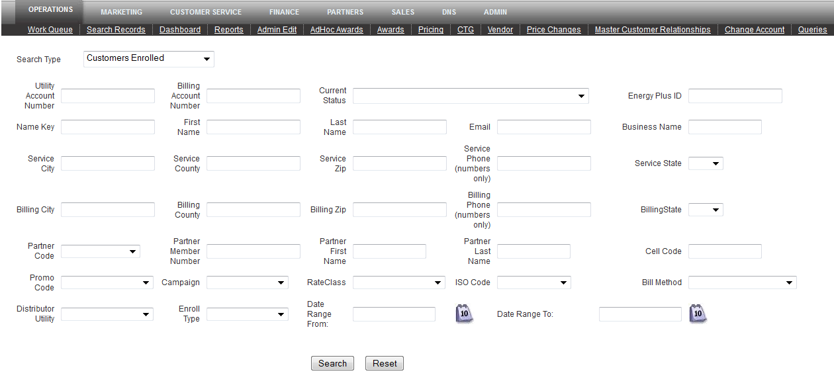
Figure 9: Search Type pull down menu
- From the Search Type pull-down menu, select the appropriate Search Type. Your options are: Customers Not Yet Enrolled, Awards, and Customers Enrolled.
- In this example, we are searching in the Customers Enrolled option.
- Enter information in the fields on the Search Records screen.
The more information you enter, the more accurate your results. For example: If you simply enter the last name ‘Smith’ the system would return hundreds of matches for the last name ‘Smith.’
- Select the Search button to begin your search. Note: If only one record matches your search criteria, the results display as shown below. If multiple records match your search criteria, the screen displays as the second screen shot shown below.
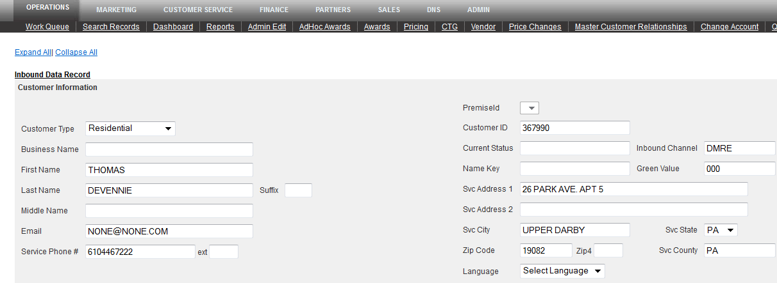
Figure 10: Search Results screen for one record returned
Figure 11: Search Results screen for multiple matching records returned
- Select the View Record link that best matches the search criteria entered. The Customer Record screen displays in the Collapsed mode.
- Select the Expand All link to expand the screen.
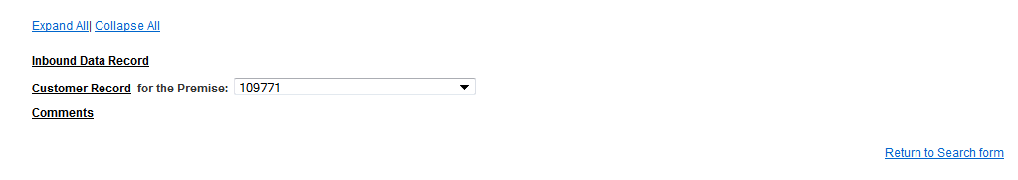
Figure 12: Search Results screen collapsed
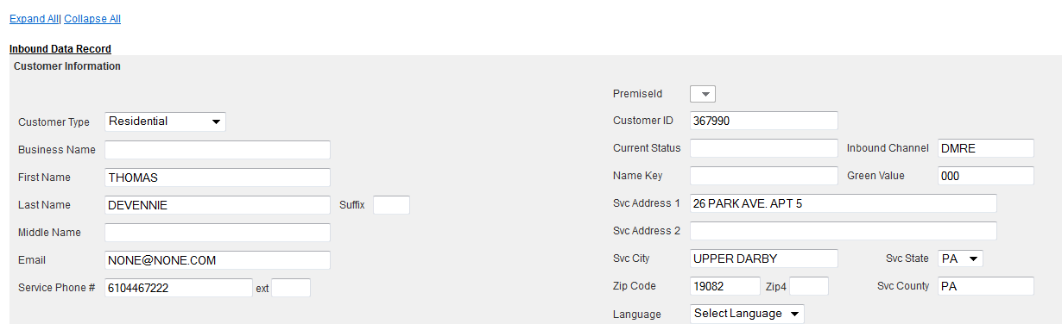
Figure 13: Search Results screen Expanded
- If you have additional records to search, select the Return to Search form link on the bottom of your screen.
Keep in mind that the Search screens for Customers Not Yet Enrolled and Customers Enrolled are very similar; however the search screen for Awards is a bit different as shown below.

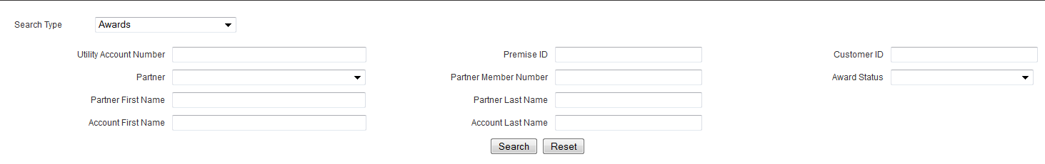
Figure 14: Awards Search screen

AdHoc Awards
Ad Hoc awards are NRG Plus’ co-brand partners’ awards created for a specific reason. For example: An AdHoc award may be created to ‘retain’ an NRG Plus customer or to sustain customer goodwill.
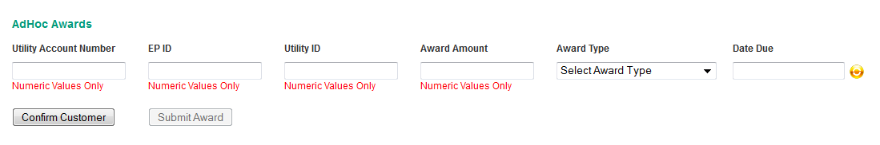
Figure 15: AdHoc Awards screen
- To create an AdHoc award, enter the NRG Plus ID number (six digits) in the EP ID field.
- Enter the Utility ID number in the Utility ID field.
The list of Utility Identification numbers is available at <INSERT LINK ONCE GUI IS COMPLETE >.
- Enter the award amount in the Award Amount field (numbers only)
- Select the type of award from the Award Type pull-down menu. Your options are: Bonus Goodwill and Bonus Retention.
- Choose the Award date due by selecting the Calendar icon next to the Date Due field and choosing the date the award is due.
- Select the Confirm Customer button to confirm the Ad Hoc award. The Customer Info & Awards Summary screen displays.
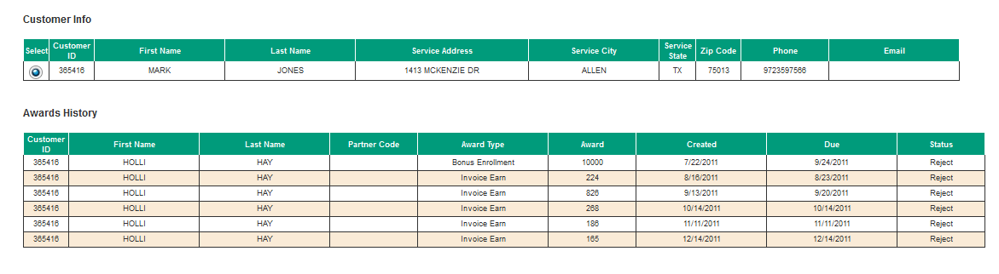
Figure 16: Customer Info & Awards Summary screen

- Check the accuracy of the customer’s information. Once you’ve confirmed that the information is correct, select the Submit Award button to submit the award.

